Hansen Wu

009867338

Assignment 1: Agent and Management Station

Agent Configuration

Communities are set in the SNMP daemon's configuration file, located at /etc/snmp/snmpd.conf. A configuration called rocommunity specifies which communities the machine belongs to. For example, “rocommunity public” means that the machine has read access on the public community.

Management Station Configuration

Under “Configure OpenNMS” on the top right corner, there's an option to “Configure SNMP Community Names by IP Address”. Here, information about the community is entered, including the SNMP version, range of IP addresses used, and the community name.

The polling is set in a config file located at /etc/opennms/poller-configuration.xml, with different intervals and settings for each protocol OpenNMS tracks (ICMP, DNS, FTP, etc). The default interval is 300,000 milliseconds, or five minutes.

Data Handling

OpenNMS comes with a PostgreSQL database which stores information about the nodes, requisitions, and other parts of OpenNMS. However, the data about the nodes or machines themselves is stored on the machine and retrieved via SNMP.

OpenNMS itself performs the data visualization. It pulls data from PostgreSQL and feeds it into graphing tools that show uptime, ping delays, and other data.

Screenshots:

This is the main page of OpenNMS showing device outages and availability.

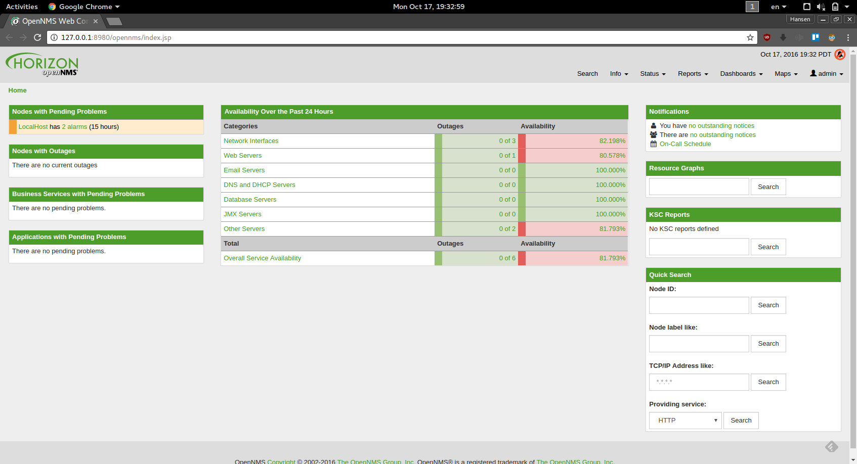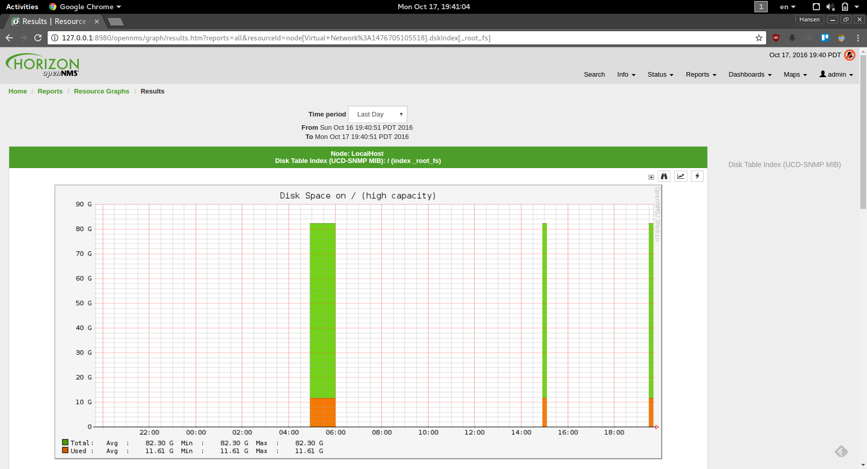

This is the chart of disk usage, generated from data retrieved via SNMP.